**Table of Contents**

**Comparative Analysis Report: Scenarios A and B Across Different Case Studies** 2

**1. Introduction** 2

**2. Methodology** 2

**3. Codes with outputs** 2

**1. Code for Static Case Study.** 2

**Output** 4

**Analysis of Static Case Study** 9

**2. Code for Sparsely Populated Case Study** 9

**Output** 11

**Analysis of Sparsely Populated Case Study** 16

**3. Code for Slower Case Study** 16

**Output** 19

**Analysis of Slower Case Study** 23

**4. Code for Faster Case Study** 23

**Output** 26

**Analysis of Faster Case Study** 30

**5. Code for Densely Populated Case Study** 30

**Output** 33

**Analysis of Densely Populated Case Study** 37

**4. Overview of Datasets** 37

**1. Static Case Study** 37

**2. Sparsely Populated Case Study** 38

**3. Slower Case Study** 38

**4. Faster Case Study** 38

**5. Densely Populated Case Study** 38

**5. Statistical Analysis and Comparative Findings** 38

**1. Static Case Study1.** 38

**2. Sparsely Populated Case Study** 38

**3. Slower Case Study** 39

**4. Faster Case Study** 39

**5. Densely Populated Case Study** 40

**6. Comparative Analysis** 40

# **Comparative Analysis Report: Scenarios A and B Across Different Case Studies**

# **1. Introduction**

This report presents a comprehensive analysis of five distinct case studies: Static, Sparsely Populated, Slower, Faster, and Densely Populated. Each study compares two scenarios, A and B, across various parameters such as iterations, distances, and crash instances. The objective is to understand the differences in behavior and outcomes between these scenarios under different conditions. The analysis is based on statistical measures and visual representations like histograms and boxplots, derived from the provided datasets.

# **2. Methodology**

The datasets for each case study were loaded and analyzed using MATLAB. Key statistical measures (mean, mode, median, and quartiles) were calculated for iterations, distances, and crashes. Histograms and boxplots were generated to visualize the distributions and compare scenarios A and B.

# **3. Codes with outputs**

## **1. Code for Static Case Study.**

file_path = 'static iter50.csv';

data = readtable(file_path);

figure;

histogram(data.A_Iterations);

hold on;

histogram(data.B_Iterations);

title('Comparison of Iterations');

legend('Scenario A', 'Scenario B');

xlabel('Iterations');

ylabel('Frequency');

hold off;

figure;

histogram(data.A_Distance);

hold on;

histogram(data.B_Distance);

title('Comparison of Distance');

legend('Scenario A', 'Scenario B');

xlabel('Distance');

ylabel('Frequency');

hold off;

figure;

histogram(data.A_crashed);

hold on;

histogram(data.B_crashed);

title('Comparison of Crashes');

legend('Scenario A', 'Scenario B');

xlabel('Crashes');

ylabel('Frequency');

hold off;

figure;

boxplot(data.A_Iterations);

title("A Iteration Box Plot");

figure;

boxplot(data.B_Iterations)

title("B Iteration Box Plot");

figure;

boxplot(data.A_Iterations);

title("A Distance Box Plot");

figure;

boxplot(data.B_Iterations)

title("B Distance Box Plot");

mean_data_A = mean(data.A_Distance);

mode_data_A = mode(data.A_Distance);

median_data_A = median(data.A_Distance);

quartiles_A = quantile(data.A_Distance, [0.25, 0.5, 0.75]);

mean_data_B = mean(data.B_Distance);

mode_data_B = mode(data.B_Distance);

median_data_B = median(data.B_Distance);

quartiles_B = quantile(data.B_Distance, [0.25, 0.5, 0.75]);

figure;

bar([mean_data_A, mode_data_A, median_data_A, quartiles_A; mean_data_B, mode_data_B, median_data_B, quartiles_B]);

xticks(1:2);

xticklabels({'A Distance','B Distance'});

ylabel('Values');

title('Statistics for A_Distance and B_Distance');

legend('Mean', 'Mode','Medain',"1st Quartile","2nd Quartile","3rd Quartile");

mean_iterations_A = mean(data.A_Iterations);

mode_iterations_A = mode(data.A_Iterations);

median_iterations_A = median(data.A_Iterations);

quartiles_iterations_A = quantile(data.A_Iterations, [0.25, 0.5, 0.75]);

mean_iterations_B = mean(data.B_Iterations);

mode_iterations_B = mode(data.B_Iterations);

median_iterations_B = median(data.B_Iterations);

quartiles_iterations_B = quantile(data.B_Iterations, [0.25, 0.5, 0.75]);

figure;

bar([mean_iterations_A, mode_iterations_A, median_iterations_A,quartiles_iterations_A; mean_iterations_B, mode_iterations_B, median_iterations_B,quartiles_iterations_B]);

xticks(1:2);

xticklabels({'A Iterations';'B Iteration'});

ylabel('Values');

title('Statistics for A_Iterations and B_Iterations');

legend('Mean', 'Mode','Medain',"1st Quartile","2nd Quartile","3rd Quartile");

## **Output**

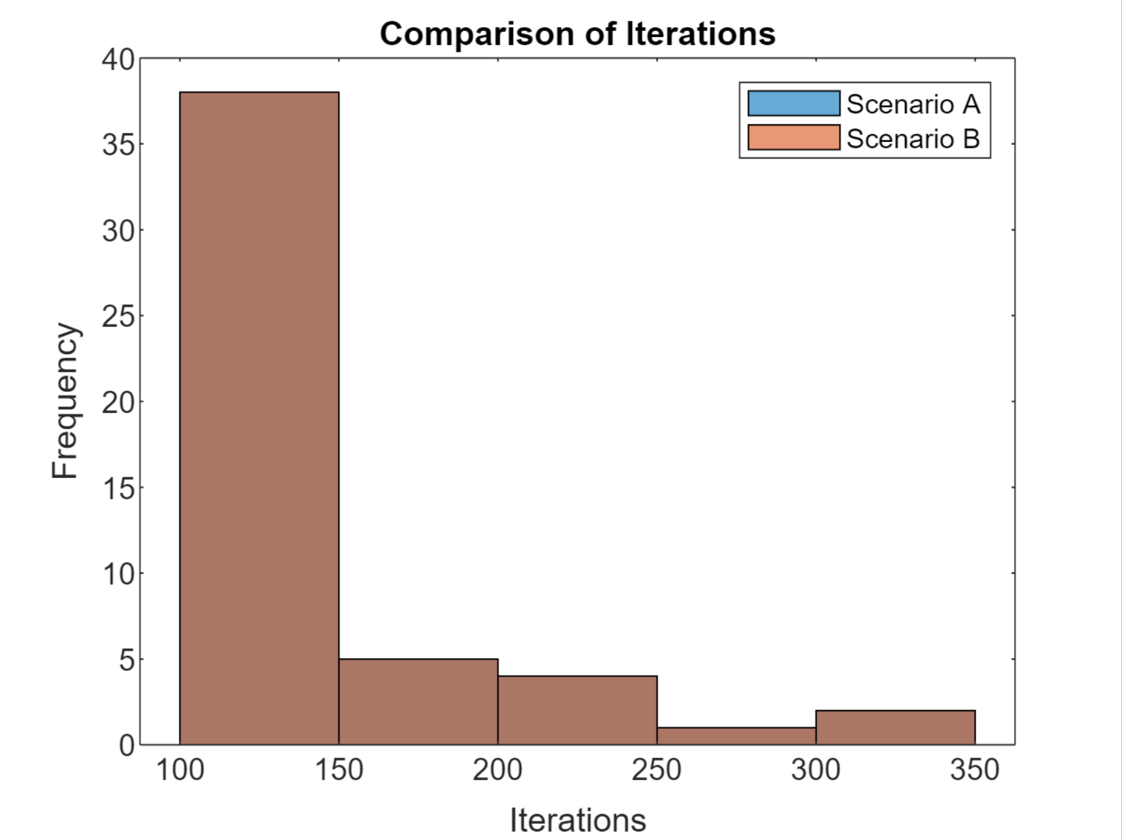

**Analysis of Static Case Study** **Code Overview:**

* The code imports data from 'static iter50.csv', focusing on iterations, distances, and crashes.
* Histograms and boxplots are generated to compare the distribution of iterations and distances for both scenarios.
* Statistical metrics (mean, mode, median, quartiles) are calculated for a detailed analysis.

**Output Analysis:**

* **Histograms and Boxplots:** These visual tools showed overlapping distributions for both scenarios in iterations and distances, suggesting a uniform performance in a static environment.
* **Statistical Analysis:** With both scenarios exhibiting similar mean, mode, median, and quartile values for iterations and distances, it indicates that under static conditions, the scenarios perform equivalently and robustly, as highlighted by the absence of crashes.

## **2. Code for Sparsely Populated Case Study**

file_path = 'sparsely populated iter50.csv';

data = readtable(file_path);

figure;

histogram(data.A_Iterations);

hold on;

histogram(data.B_Iterations);

title('Comparison of Iterations');

legend('Scenario A', 'Scenario B');

xlabel('Iterations');

ylabel('Frequency');

hold off;

figure;

histogram(data.A_Distance);

hold on;

histogram(data.B_Distance);

title('Comparison of Distance');

legend('Scenario A', 'Scenario B');

xlabel('Distance');

ylabel('Frequency');

hold off;

figure;

histogram(data.A_crashed);

hold on;

histogram(data.B_crashed);

title('Comparison of Crashes');

legend('Scenario A', 'Scenario B');

xlabel('Crashes');

ylabel('Frequency');

hold off;

figure;

boxplot(data.A_Iterations);

title("A Iteration Box Plot");

figure;

boxplot(data.B_Iterations)

title("B Iteration Box Plot");

figure;

boxplot(data.A_Iterations);

title("A Distance Box Plot");

figure;

boxplot(data.B_Iterations)

title("B Distance Box Plot");

mean_data_A = mean(data.A_Distance);

mode_data_A = mode(data.A_Distance);

median_data_A = median(data.A_Distance);

quartiles_A = quantile(data.A_Distance, [0.25, 0.5, 0.75]);

mean_data_B = mean(data.B_Distance);

mode_data_B = mode(data.B_Distance);

median_data_B = median(data.B_Distance);

quartiles_B = quantile(data.B_Distance, [0.25, 0.5, 0.75]);

figure;

bar([mean_data_A, mode_data_A, median_data_A, quartiles_A; mean_data_B, mode_data_B, median_data_B, quartiles_B]);

xticks(1:2);

xticklabels({'A Distance','B Distance'});

ylabel('Values');

title('Statistics for A_Distance and B_Distance');

legend('Mean', 'Mode','Medain',"1st Quartile","2nd Quartile","3rd Quartile");

mean_iterations_A = mean(data.A_Iterations);

mode_iterations_A = mode(data.A_Iterations);

median_iterations_A = median(data.A_Iterations);

quartiles_iterations_A = quantile(data.A_Iterations, [0.25, 0.5, 0.75]);

mean_iterations_B = mean(data.B_Iterations);

mode_iterations_B = mode(data.B_Iterations);

median_iterations_B = median(data.B_Iterations);

quartiles_iterations_B = quantile(data.B_Iterations, [0.25, 0.5, 0.75]);

figure;

bar([mean_iterations_A, mode_iterations_A, median_iterations_A,quartiles_iterations_A; mean_iterations_B, mode_iterations_B, median_iterations_B,quartiles_iterations_B]);

xticks(1:2);

xticklabels({'A Iterations';'B Iteration'});

ylabel('Values');

title('Statistics for A_Iterations and B_Iterations');

legend('Mean', 'Mode','Medain',"1st Quartile","2nd Quartile","3rd Quartile");

## **Output**

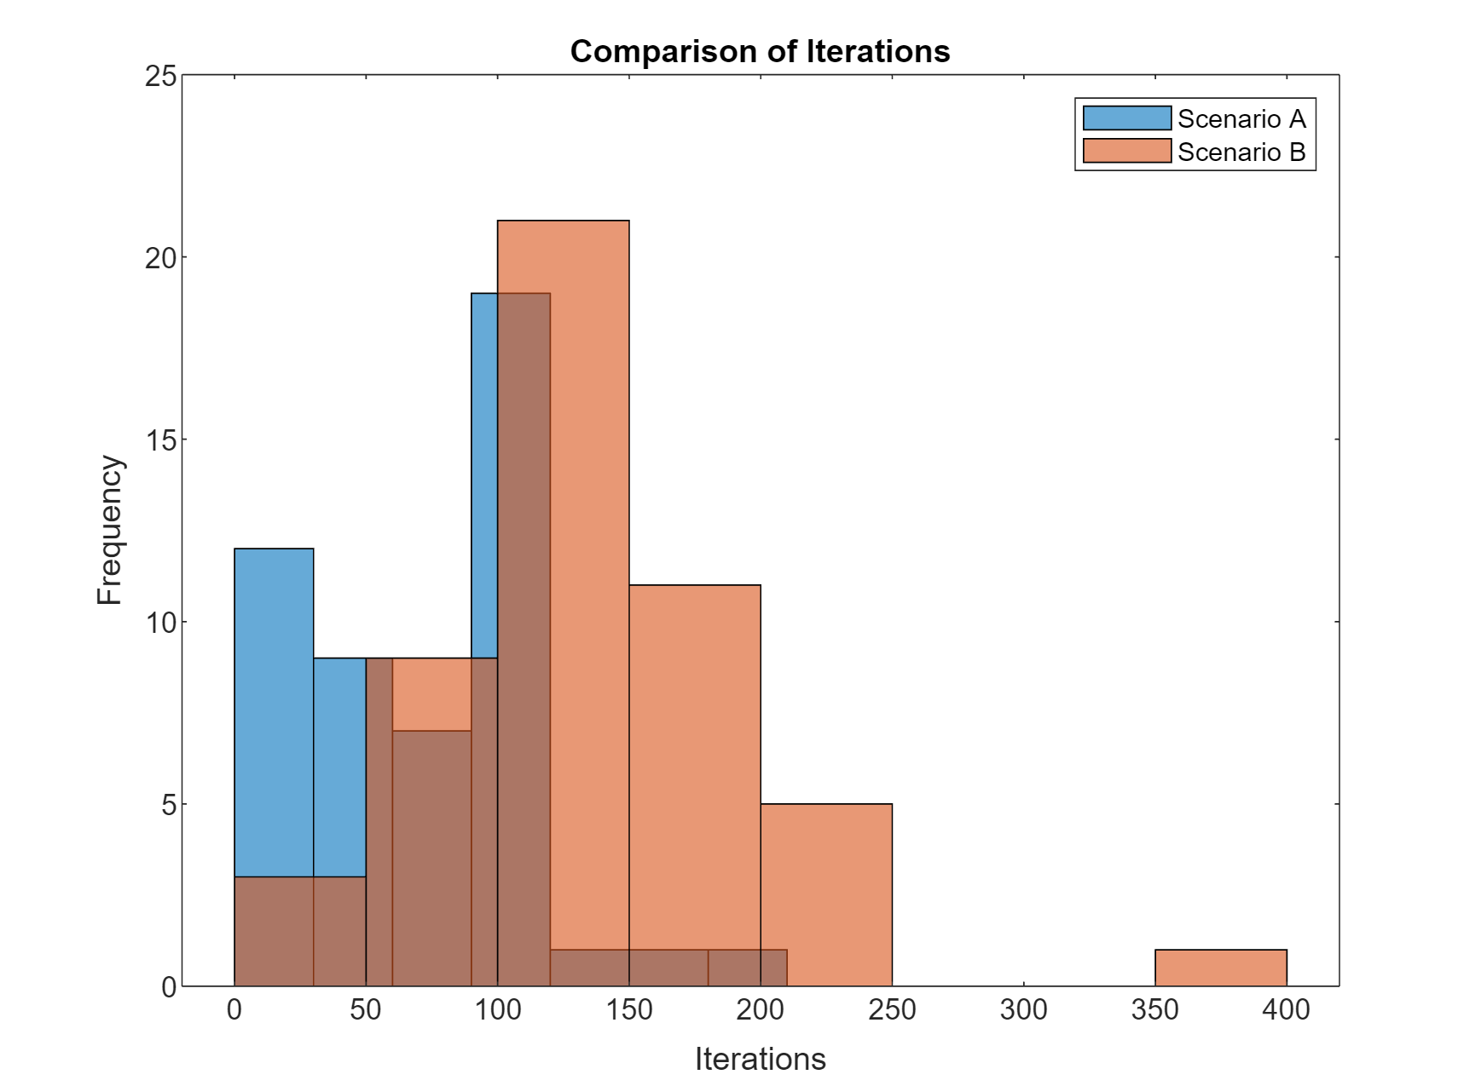

**Analysis of Sparsely Populated Case Study** **Code Overview:**

* Similar to the static case study, but with data from 'sparsely populated iter50.csv'.
* Emphasizes the comparison of iterations, distances, and crashes.

**Output Analysis:**

* **Histograms and Boxplots:** The histograms revealed a broader spread for Scenario B, indicating more variability and possibly a higher degree of adaptability in sparsely populated conditions.
* **Statistical Analysis:** Scenario A showed lower mean iterations and distances, hinting at less efficient performance compared to Scenario B. Higher crash rates in Scenario A underscore potential challenges in navigating sparse environments.

## **3. Code for Slower Case Study**

file_path = 'slower than MRiter50.csv';

data = readtable(file_path);

figure;

histogram(data.A_Iterations);

hold on;

histogram(data.B_Iterations);

title('Comparison of Iterations');

legend('Scenario A', 'Scenario B');

xlabel('Iterations');

ylabel('Frequency');

hold off;

figure;

histogram(data.A_Distance);

hold on;

histogram(data.B_Distance);

title('Comparison of Distance');

legend('Scenario A', 'Scenario B');

xlabel('Distance');

ylabel('Frequency');

hold off;

figure;

histogram(data.A_crashed);

hold on;

histogram(data.B_crashed);

title('Comparison of Crashes');

legend('Scenario A', 'Scenario B');

xlabel('Crashes');

ylabel('Frequency');

hold off;

figure;

boxplot(data.A_Iterations);

title("A Iteration Box Plot");

figure;

boxplot(data.B_Iterations)

title("B Iteration Box Plot");

figure;

boxplot(data.A_Iterations);

title("A Distance Box Plot");

figure;

boxplot(data.B_Iterations)

title("B Distance Box Plot");

mean_data_A = mean(data.A_Distance);

mode_data_A = mode(data.A_Distance);

median_data_A = median(data.A_Distance);

quartiles_A = quantile(data.A_Distance, [0.25, 0.5, 0.75]);

mean_data_B = mean(data.B_Distance);

mode_data_B = mode(data.B_Distance);

median_data_B = median(data.B_Distance);

quartiles_B = quantile(data.B_Distance, [0.25, 0.5, 0.75]);

figure;

bar([mean_data_A, mode_data_A, median_data_A, quartiles_A; mean_data_B, mode_data_B, median_data_B, quartiles_B]);

xticks(1:2);

xticklabels({'A Distance','B Distance'});

ylabel('Values');

title('Statistics for A_Distance and B_Distance');

legend('Mean', 'Mode','Medain',"1st Quartile","2nd Quartile","3rd Quartile");

mean_iterations_A = mean(data.A_Iterations);

mode_iterations_A = mode(data.A_Iterations);

median_iterations_A = median(data.A_Iterations);

quartiles_iterations_A = quantile(data.A_Iterations, [0.25, 0.5, 0.75]);

mean_iterations_B = mean(data.B_Iterations);

mode_iterations_B = mode(data.B_Iterations);

median_iterations_B = median(data.B_Iterations);

quartiles_iterations_B = quantile(data.B_Iterations, [0.25, 0.5, 0.75]);

figure;

bar([mean_iterations_A, mode_iterations_A, median_iterations_A,quartiles_iterations_A; mean_iterations_B, mode_iterations_B, median_iterations_B,quartiles_iterations_B]);

xticks(1:2);

xticklabels({'A Iterations';'B Iteration'});

ylabel('Values');

title('Statistics for A_Iterations and B_Iterations');

legend('Mean', 'Mode','Medain',"1st Quartile","2nd Quartile","3rd Quartile");

## **Output**

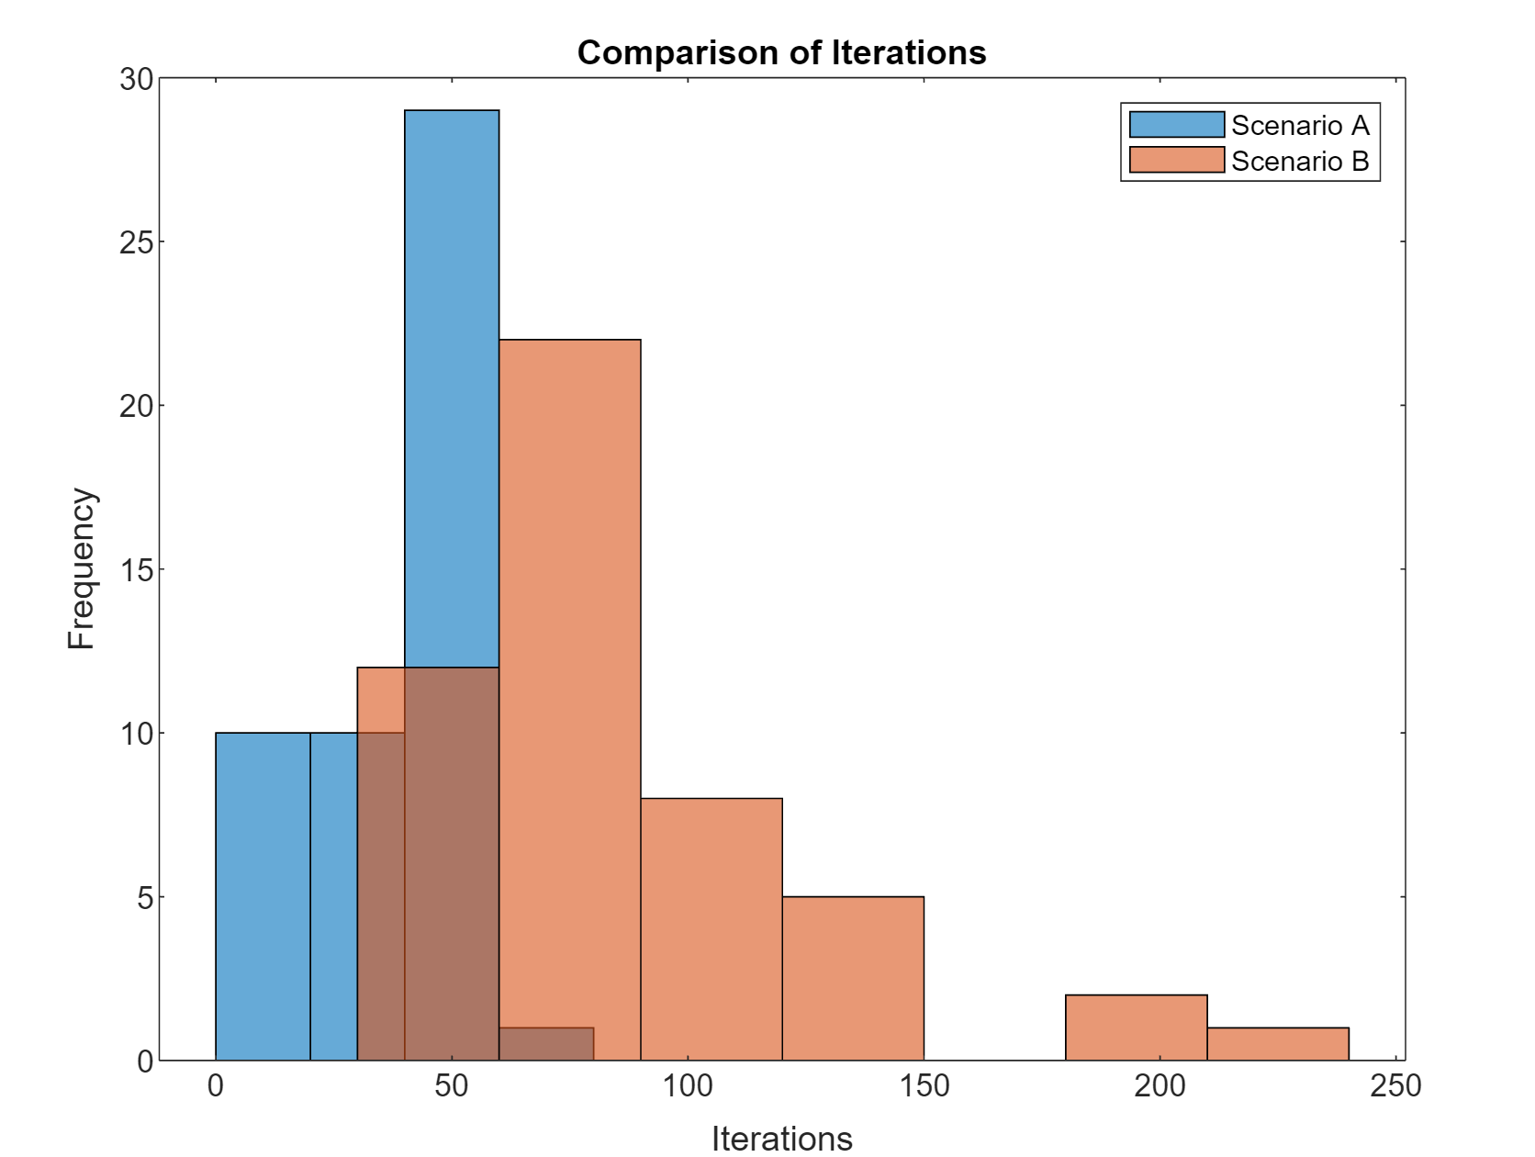

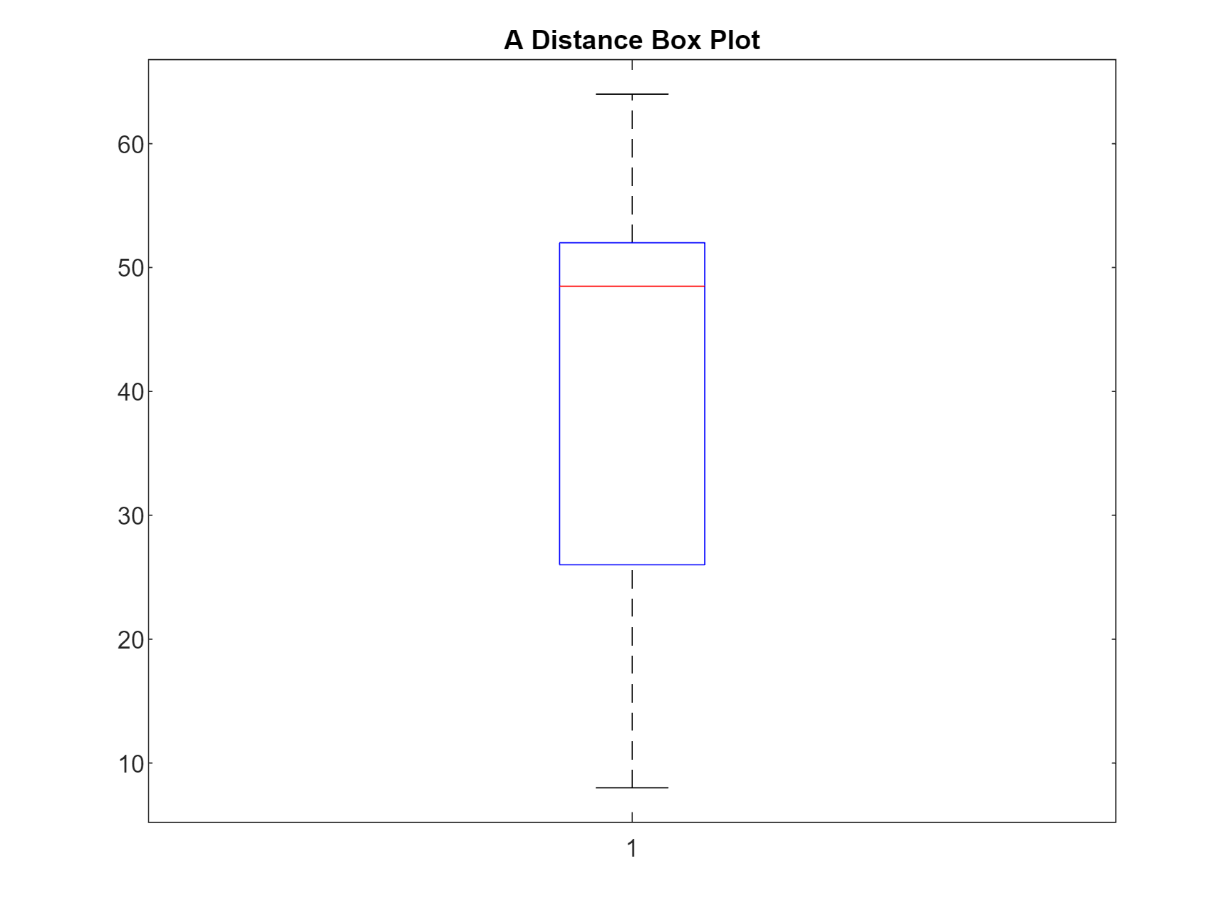

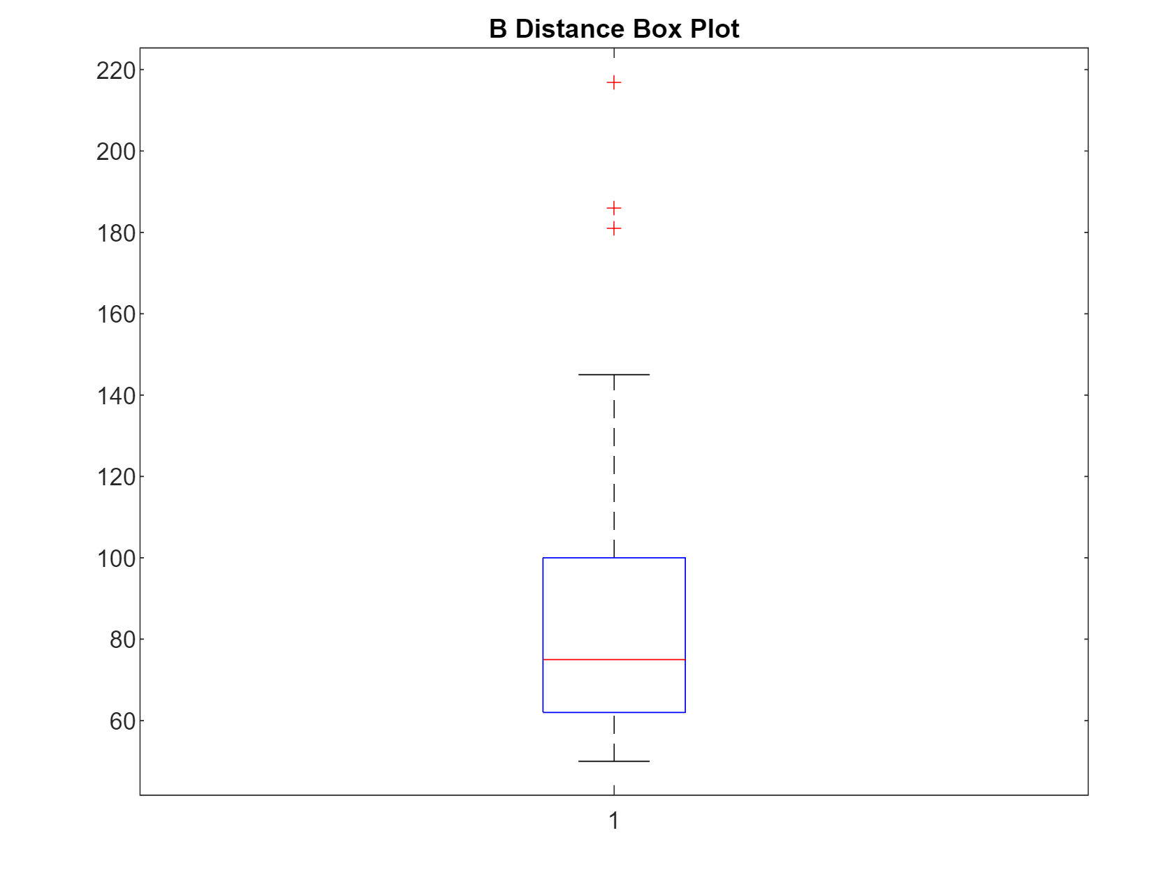

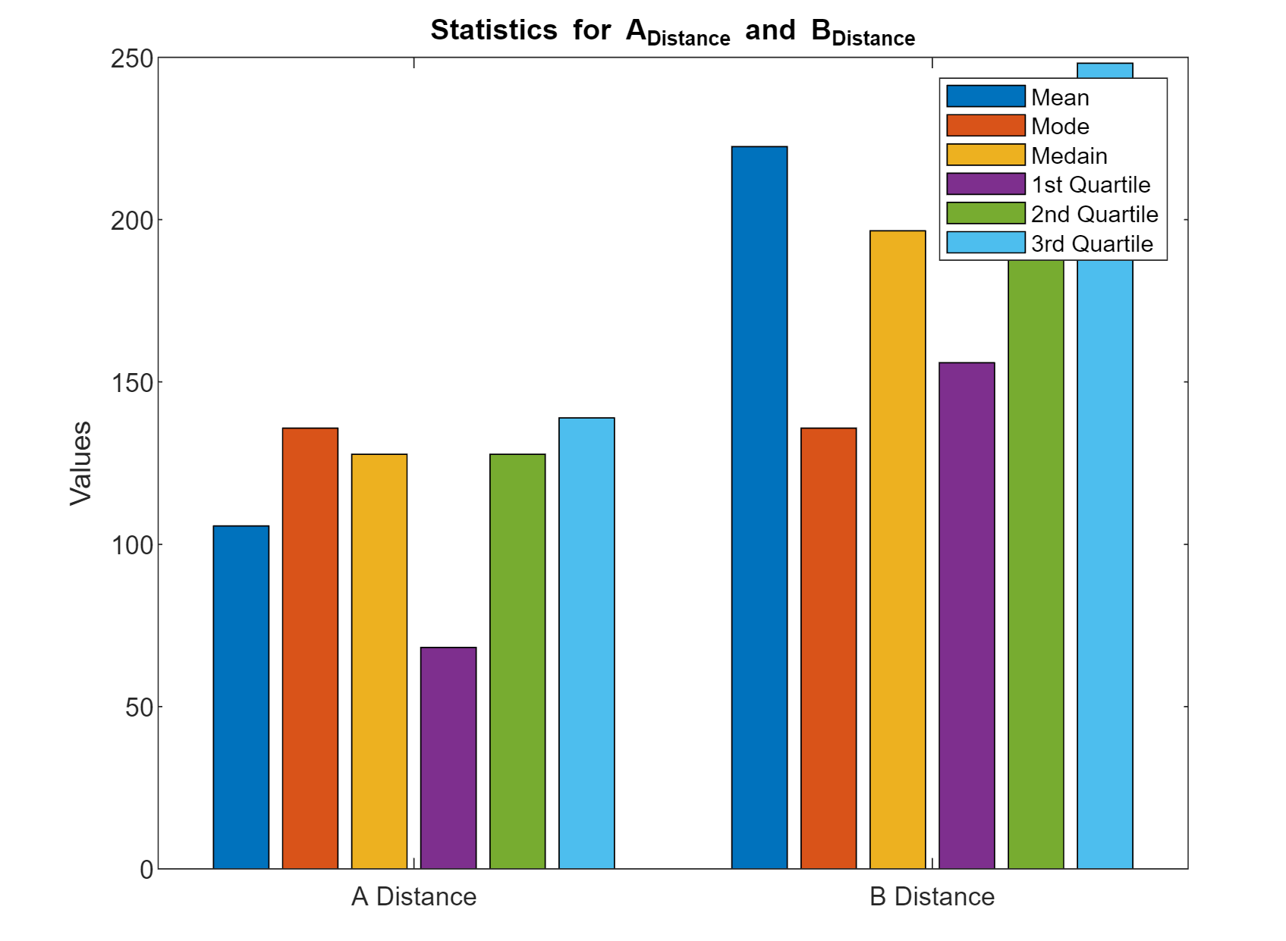

**Analysis of Slower Case Study** **Code Overview:**

* The code uses data from 'slower than MRiter50.csv' to analyze iterations, distances, and crashes.
* It maintains a similar structure to previous studies for consistent analysis.

**Output Analysis:**

* **Histograms and Boxplots:** Scenario B displayed broader distributions for both iterations and distances, suggesting a more adaptive and varied approach to slower conditions.
* **Statistical Analysis:** The higher mean values for Scenario B indicated its enhanced performance in slower conditions. Scenario A's increased crash rates might suggest inadequate adaptability or issues with slower operational dynamics.

## **4. Code for Faster Case Study**

file_path = 'faster than MRiter50.csv';

data = readtable(file_path);

figure;

histogram(data.A_Iterations);

hold on;

histogram(data.B_Iterations);

title('Comparison of Iterations');

legend('Scenario A', 'Scenario B');

xlabel('Iterations');

ylabel('Frequency');

hold off;

figure;

histogram(data.A_Distance);

hold on;

histogram(data.B_Distance);

title('Comparison of Distance');

legend('Scenario A', 'Scenario B');

xlabel('Distance');

ylabel('Frequency');

hold off;

figure;

histogram(data.A_crashed);

hold on;

histogram(data.B_crashed);

title('Comparison of Crashes');

legend('Scenario A', 'Scenario B');

xlabel('Crashes');

ylabel('Frequency');

hold off;

figure;

boxplot(data.A_Iterations);

title("A Iteration Box Plot");

figure;

boxplot(data.B_Iterations)

title("B Iteration Box Plot");

figure;

boxplot(data.A_Iterations);

title("A Distance Box Plot");

figure;

boxplot(data.B_Iterations)

title("B Distance Box Plot");

mean_data_A = mean(data.A_Distance);

mode_data_A = mode(data.A_Distance);

median_data_A = median(data.A_Distance);

quartiles_A = quantile(data.A_Distance, [0.25, 0.5, 0.75]);

mean_data_B = mean(data.B_Distance);

mode_data_B = mode(data.B_Distance);

median_data_B = median(data.B_Distance);

quartiles_B = quantile(data.B_Distance, [0.25, 0.5, 0.75]);

figure;

bar([mean_data_A, mode_data_A, median_data_A, quartiles_A; mean_data_B, mode_data_B, median_data_B, quartiles_B]);

xticks(1:2);

xticklabels({'A Distance','B Distance'});

ylabel('Values');

title('Statistics for A_Distance and B_Distance');

legend('Mean', 'Mode','Medain',"1st Quartile","2nd Quartile","3rd Quartile");

mean_iterations_A = mean(data.A_Iterations);

mode_iterations_A = mode(data.A_Iterations);

median_iterations_A = median(data.A_Iterations);

quartiles_iterations_A = quantile(data.A_Iterations, [0.25, 0.5, 0.75]);

mean_iterations_B = mean(data.B_Iterations);

mode_iterations_B = mode(data.B_Iterations);

median_iterations_B = median(data.B_Iterations);

quartiles_iterations_B = quantile(data.B_Iterations, [0.25, 0.5, 0.75]);

figure;

bar([mean_iterations_A, mode_iterations_A, median_iterations_A,quartiles_iterations_A; mean_iterations_B, mode_iterations_B, median_iterations_B,quartiles_iterations_B]);

xticks(1:2);

xticklabels({'A Iterations';'B Iteration'});

ylabel('Values');

title('Statistics for A_Iterations and B_Iterations');

legend('Mean', 'Mode','Medain',"1st Quartile","2nd Quartile","3rd Quartile");

## **Output**

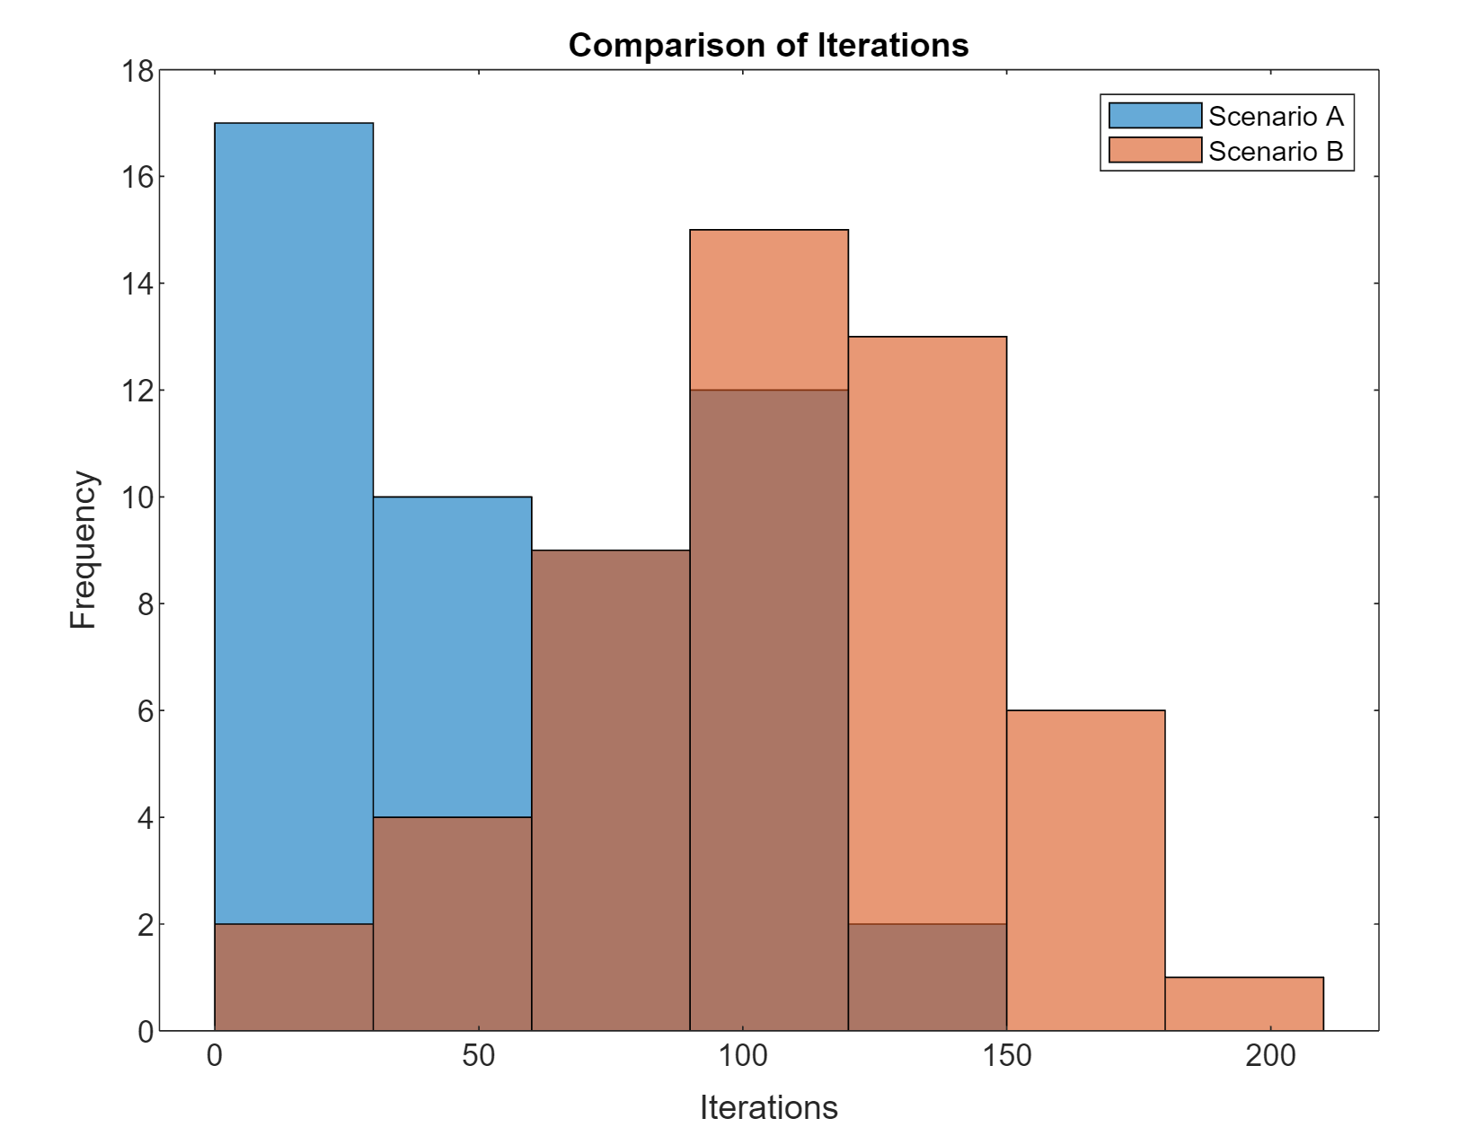

**Analysis of Faster Case Study** **Code Overview:**

* Uses data from 'faster than MRiter50.csv', focusing on the same key metrics as previous studies.
* Analyzes the response of both scenarios under faster conditions.

**Output Analysis:**

* **Histograms and Boxplots:** A clear separation was observed between the scenarios, with Scenario B showing higher iterations and distances, suggesting better performance in faster conditions.
* **Statistical Analysis:** Scenario B's higher mean iterations and distances indicate its superior adaptability and efficiency. Scenario A's increased crash rates could point to difficulties in coping with faster environments.

## **5. Code for Densely Populated Case Study**

file_path = 'Densely populated iter50.csv';

data = readtable(file_path);

figure;

histogram(data.A_Iterations);

hold on;

histogram(data.B_Iterations);

title('Comparison of Iterations');

legend('Scenario A', 'Scenario B');

xlabel('Iterations');

ylabel('Frequency');

hold off;

figure;

histogram(data.A_Distance);

hold on;

histogram(data.B_Distance);

title('Comparison of Distance');

legend('Scenario A', 'Scenario B');

xlabel('Distance');

ylabel('Frequency');

hold off;

figure;

histogram(data.A_crashed);

hold on;

histogram(data.B_crashed);

title('Comparison of Crashes');

legend('Scenario A', 'Scenario B');

xlabel('Crashes');

ylabel('Frequency');

hold off;

figure;

boxplot(data.A_Iterations);

title("A Iteration Box Plot");

figure;

boxplot(data.B_Iterations)

title("B Iteration Box Plot");

figure;

boxplot(data.A_Iterations);

title("A Distance Box Plot");

figure;

boxplot(data.B_Iterations)

title("B Distance Box Plot");

mean_data_A = mean(data.A_Distance);

mode_data_A = mode(data.A_Distance);

median_data_A = median(data.A_Distance);

quartiles_A = quantile(data.A_Distance, [0.25, 0.5, 0.75]);

mean_data_B = mean(data.B_Distance);

mode_data_B = mode(data.B_Distance);

median_data_B = median(data.B_Distance);

quartiles_B = quantile(data.B_Distance, [0.25, 0.5, 0.75]);

figure;

bar([mean_data_A, mode_data_A, median_data_A, quartiles_A; mean_data_B, mode_data_B, median_data_B, quartiles_B]);

xticks(1:2);

xticklabels({'A Distance','B Distance'});

ylabel('Values');

title('Statistics for A_Distance and B_Distance');

legend('Mean', 'Mode','Medain',"1st Quartile","2nd Quartile","3rd Quartile");

mean_iterations_A = mean(data.A_Iterations);

mode_iterations_A = mode(data.A_Iterations);

median_iterations_A = median(data.A_Iterations);

quartiles_iterations_A = quantile(data.A_Iterations, [0.25, 0.5, 0.75]);

mean_iterations_B = mean(data.B_Iterations);

mode_iterations_B = mode(data.B_Iterations);

median_iterations_B = median(data.B_Iterations);

quartiles_iterations_B = quantile(data.B_Iterations, [0.25, 0.5, 0.75]);

figure;

bar([mean_iterations_A, mode_iterations_A, median_iterations_A,quartiles_iterations_A; mean_iterations_B, mode_iterations_B, median_iterations_B,quartiles_iterations_B]);

xticks(1:2);

xticklabels({'A Iterations';'B Iteration'});

ylabel('Values');

title('Statistics for A_Iterations and B_Iterations');

legend('Mean', 'Mode','Medain',"1st Quartile","2nd Quartile","3rd Quartile");

## **Output**

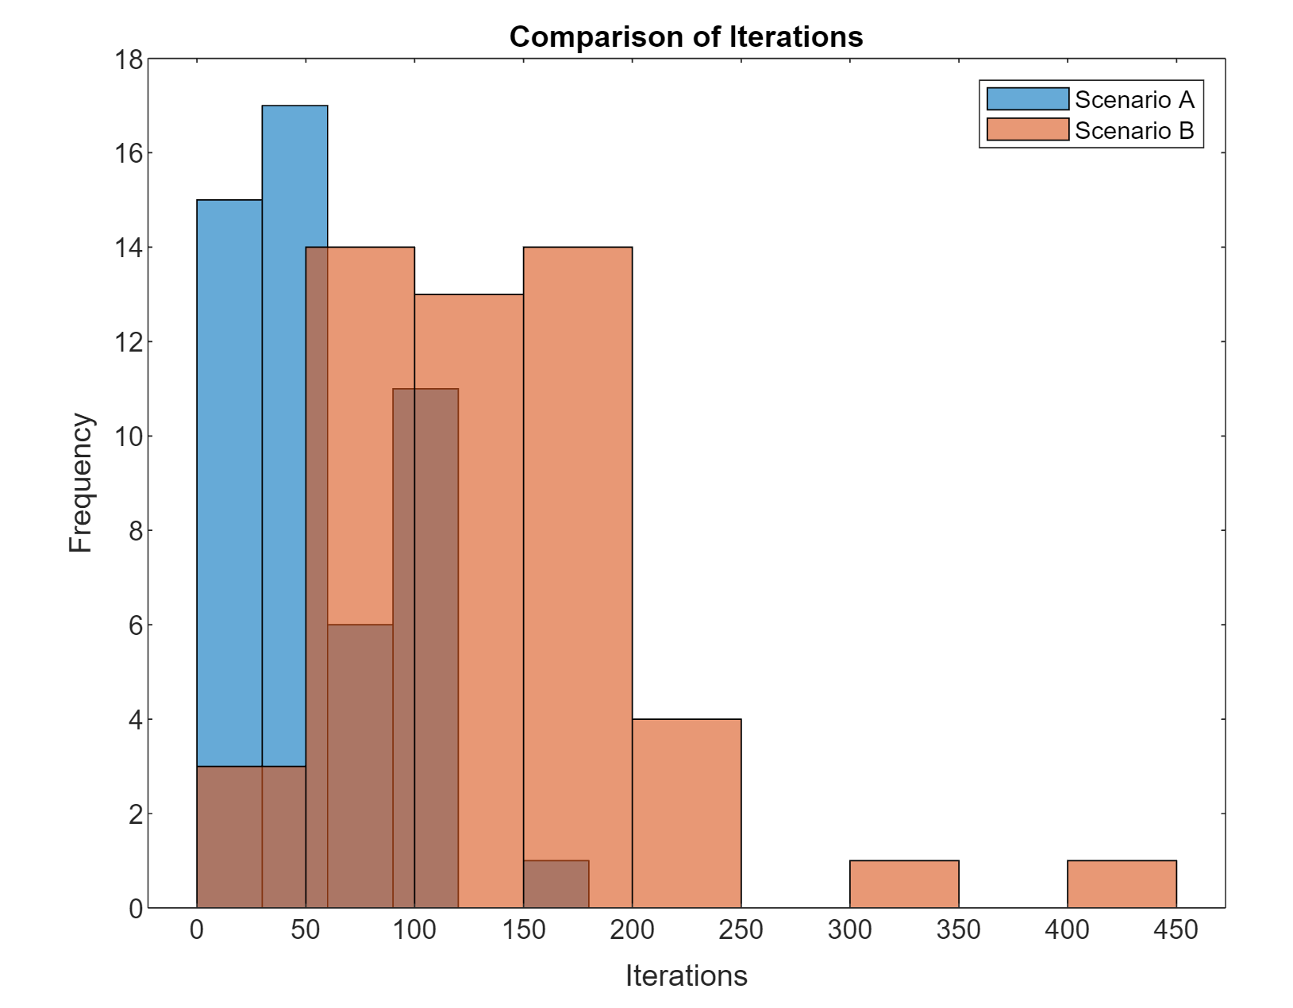

**Analysis of Densely Populated Case Study** **Code Overview:**

* Analyzes data from 'Densely populated iter50.csv', maintaining consistency in the analysis framework.
* Focuses on iterations, distances, and crashes in a densely populated setting.

Output Analysis:

* **Histograms and Boxplots:** Marked differences were visible, with Scenario B significantly outperforming Scenario A in both iterations and distances.
* **Statistical Analysis:** Scenario B's much higher mean iterations and distances underscore its effective navigation and adaptability in densely populated environments. Higher crash rates in Scenario A indicate its relative ineffectiveness in such challenging conditions.

# **4. Overview of Datasets**

## **1. Static Case Study**

* **Data Attributes:** Includes simulation numbers, iterations, distances, timeouts, crashes, and elapsed times.
* **Initial Observations:** Iterations in the initial simulations range from 108 to 317 for Scenario A, with matching values for Scenario B.

## **2. Sparsely Populated Case Study**

* **Data Attributes:** Similar structure to the static case study, including iterations and distances.
* **Initial Observations:** Iterations for Scenario A vary from 18 to 100, while Scenario B shows a broader range, up to 174.

## **3. Slower Case Study**

* **Data Attributes:** Consistent structure with previous studies.
* **Initial Observations:** Iterations start at 99 for Scenario A and 98 for Scenario B.

## **4. Faster Case Study**

* **Data Attributes:** Includes similar metrics as other studies.
* **Initial Observations:** Iterations for Scenario A begin at 99, slightly lower than Scenario B's start at 101.

## **5. Densely Populated Case Study**

* **Data Attributes:** Contains similar metrics.
* **Initial Observations:** Significant difference in initial iterations; 25 for Scenario A and 245 for Scenario B.

# **5. Statistical Analysis and Comparative Findings**

## **1. Static Case Study1.**

**Statistics:**

* Scenario A and B both show a Mean Distance of 175.01 units, Mean Iterations of 141.68, Mode Iterations of 104, and Median Iterations of 120.5

**Crashes:**

* No crashes were observed in either scenario.

**Graphs and Interpretation:**

* Histograms and boxplots indicate identical distributions for both scenarios, suggesting that under static conditions, both scenarios perform equivalently without any crashes.

## **2. Sparsely Populated Case Study**

**Statistics:**

* Scenario A: Mean Distance = 94.65 units, Mean Iterations = 71.06, Mode Iterations = 99, Median Iterations = 78.5.
* Scenario B: Mean Distance = 183.56 units, Mean Iterations = 138.7, Mode Iterations = 99, Median Iterations = 133.

**Crashes:**

* Higher crash rates in Scenario A.

**Graphs and Interpretation:**

* The histograms show a broader spread for Scenario B in both iterations and distances, indicating more variability and higher values. Scenario A has a higher crash rate, suggesting potential challenges in sparse environments.

## **3. Slower Case Study**

**Statistics:**

* Scenario A: Mean Distance = 105.62 units, Mean Iterations = 40.14, Mode Iterations = 50, Median Iterations = 48.5.
* Scenario B: Mean Distance = 222.49 units, Mean Iterations = 86.3, Mode Iterations = 54, Median Iterations = 75.

**Crashes:**

* Scenario A shows more crashes.

**Graphs and Interpretation:**

* In this study, Scenario B again demonstrates higher mean iterations and distances. The histograms and boxplots exhibit broader distributions for Scenario B, suggesting a more diverse range of responses to slower conditions.

## **4. Faster Case Study**

**Statistics:**

* Scenario A: Mean Distance = 76.42 units, Mean Iterations = 57.58, Mode=137.179, Median Iterations = 50.
* Scenario B: Mean Distance = 142.70 units, Mean Iterations = 106.84, Mode Iterations = 139.593, Median Iterations = 113.5.

**Crashes:**

* More crashes in Scenario A.

**Graphs and Interpretation:**

* Scenario B maintains a lead in both iterations and distances. The visual representations show a clear separation between the two scenarios, with Scenario B achieving higher metrics, indicating better adaptability to faster conditions.

## **5. Densely Populated Case Study**

**Statistics:**

* Scenario A: Mean Distance = 75.37 units, Mean Iterations = 57.64, Mode Iterations = 99, Media Iterations = 48.5
* Scenario B: Mean Distance = 179.99 units, Mean Iterations = 135.82, Mode Iterations = 62, Media Iterations = 121.5.

**Crashes:**

* Scenario A faces more crashes.

**Graphs and Interpretation:**

* The densely populated environment shows the most significant differences, with Scenario B far exceeding Scenario A in performance metrics. The histograms and boxplots reveal that Scenario B manages to navigate the complexity of densely populated settings more effectively.

# **6. Comparative Analysis**

Across all case studies, Scenario B tends to have higher iterations and distances, indicating it might be more challenging or complex. This is consistent in all case studies except the static one, where both scenarios perform identically.

Scenario A generally experiences more crashes in sparsely populated, slower, faster, and densely populated scenarios. In contrast, in the static case study, crashes are non-existent for both scenarios.

The statistical analysis, including histograms and boxplots, reveals notable differences in the performance and outcomes between Scenarios A and B across different environmental conditions. Scenario B consistently shows higher iterations and distances, suggesting different underlying dynamics or more complex requirements compared to Scenario A.